**--Q1) Create view vw_updatable_products (use same query whatever I used in the training)**

**--Try updating view with below query and see if the product table also gets updated.**

**--Update query:**

**--UPDATE updatable_products SET unit_price = unit_price * 1.1 WHERE units_in_stock < 10;**

**Query:**

CREATE OR REPLACE VIEW vw_updatable_products AS

SELECT product_id,product_name,supplier_id,category_id,quantity_per_unit,unit_price,units_in_stock,units_on_order,reorder_level,discontinued

FROM

products

WHERE

discontinued = 0;

SELECT product_id, product_name, unit_price, units_in_stock FROM vw_updatable_products WHERE units_in_stock < 10;

UPDATE vw_updatable_products

SET unit_price = unit_price * 1.1

WHERE units_in_stock < 10;

**Output:**

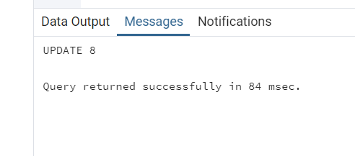

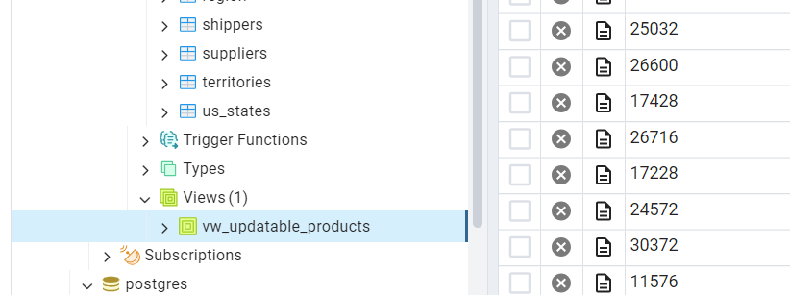

**Q2) --2. Transaction:--Update the product price for products by 10% in category id=1.--Try COMMIT and ROLLBACK and observe what happens. -- Start transaction**

**Query:**

BEGIN;

SELECT product_id, product_name, unit_price AS original_price

FROM products

WHERE category_id = 1;

UPDATE products

SET limit_price = unit_price * 1.10

WHERE category_id = 1;

SELECT product_id, product_name, unit_price AS updated_price

FROM products

WHERE category_id = 1;

COMMIT;

SELECT product_id, product_name, unit_price AS final_price

FROM products

WHERE category_id = 1;

BEGIN;

SELECT product_id, product_name, unit_price AS original_price

FROM products

WHERE category_id = 1;

UPDATE products

SET unit_price = unit_price * 1.10

WHERE category_id = 1;

SELECT product_id, product_name, unit_price AS updated_price

FROM products

WHERE category_id = 1;

ROLLBACK;

SELECT product_id, product_name, unit_price AS final_price

FROM products

WHERE category_id = 1;

**Output:**

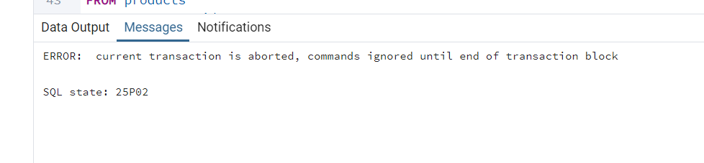

**Q3) --3. Create a regular view which will have below details (Need to do joins):--Employee_id,**

**--Employee_full_name,**

**--Title,**

**--Territory_id,**

**--territory_description,**

**--region_description**

**Query:**

CREATE OR REPLACE VIEW vw_employee_territories AS

SELECT

e.employee_id,

CONCAT(e.first_name, ' ', e.last_name) AS employee_full_name,

e.title,

t.territory_id,

t.territory_description,

r.region_description

FROM

employees e

JOIN

employee_territories et ON e.employee_id = et.employee_id

JOIN

territories t ON et.territory_id = t.territory_id

JOIN

region r ON t.region_id = r.region_id

ORDER BY

r.region_description,

t.territory_description,

employee_full_name;

**Output:**

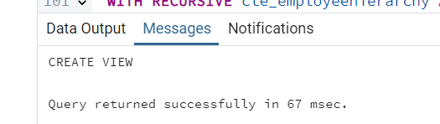

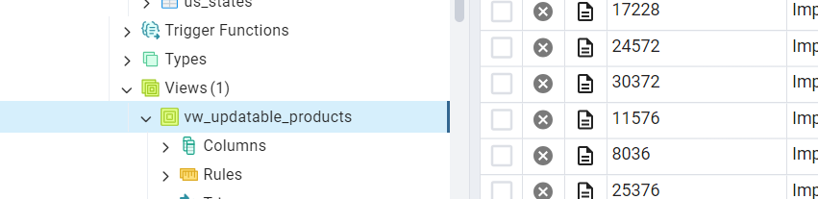

**Q4) --4.Create a recursive CTE based on Employee Hierarchy**

**Query:**

WITH RECURSIVE cte_employeehierarchy AS (

SELECT

employee_id,

first_name,

last_name,

reports_to,

0 AS level

FROM

employees

WHERE

reports_to IS NULL

UNION ALL

SELECT

e.employee_id,

e.first_name,

e.last_name,

e.reports_to,

eh.level + 1

FROM

employees e

JOIN

cte_employeehierarchy eh

ON

e.reports_to = eh.employee_id

)

SELECT

level,

employee_id,

first_name || ' ' || last_name AS employee_name

FROM

cte_employeehierarchy

ORDER BY

level,employee_id;

SELECT employee_id, first_name, reports_to FROM employees;

Output:

